Emily Swanson
Honors Physics
The Pendulum Lab

Learning Targets:

LT1: I can use the conservation of mechanical energy (potential energy and kinetic energy) to calculate the maximum velocity of a swinging pendulum.
LT2: I can analyze the factors that determine the maximum kinetic energy of a swinging pendulum.

Materials:

-Pendulum stand
-Pendulum
- 2 Rulers/ meterstick
-Protractor
Protractor
Procedure:

- Gather materials
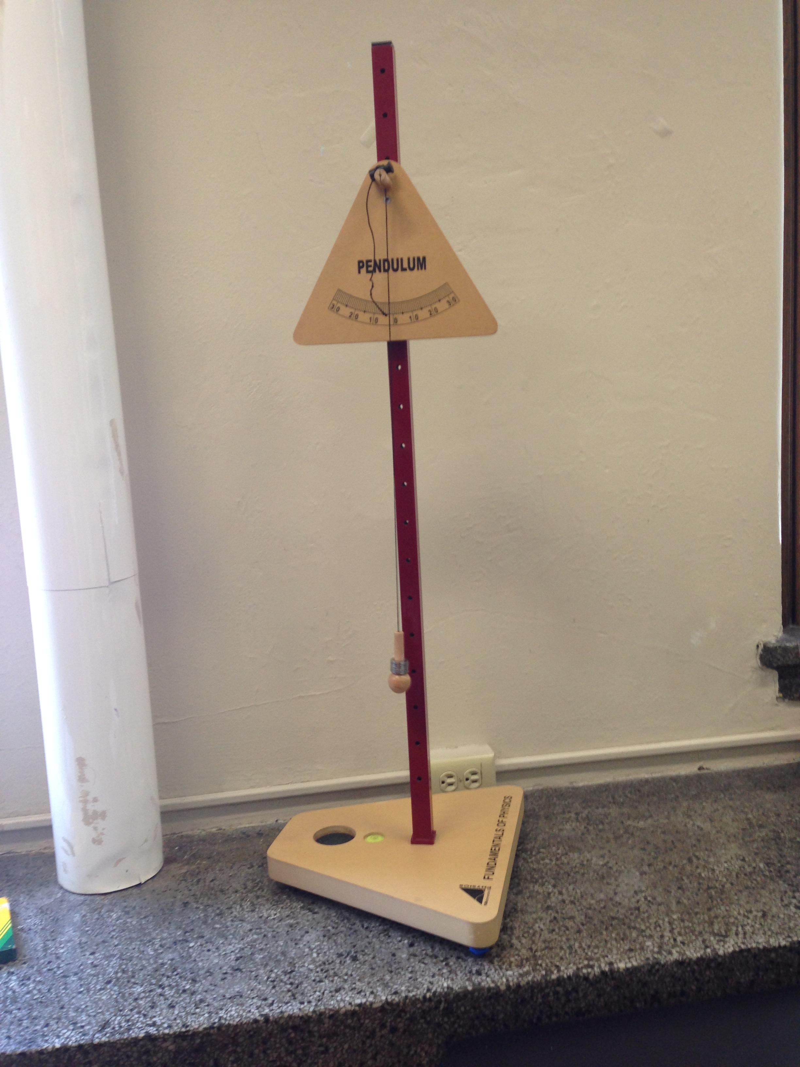
- Measure length of the string to the bottom of the ball (pendulum)
- Attach protractor to pendulum stand (see picture)
Pendulum
- Attach pendulum to pendulum stand
- Measure the height of the pendulum stand from the knob on which the pendulum hangs to the table
- Pull pendulum back at the instructed angle and hold it there, then hold a clear colored ruler straight under the ball parallel to the table
Pendulum
Stand
- Measure the distance from the table to the horizontal ruler. Make sure the two rulers are perpendicular
- Release the ball at the given angle and record your observation (3 trails)

Data Table:
Observations of the Oscillations
Trials θ Distance to Ball Observations
#1 | 30° | 47 cm. | Shaky release, longer and faster oscillations
#2 | 20° | 44 cm. | Smooth, shorter, and slower oscillations
#3 | 10° | 41 cm. | Smooth release and shorter oscillations
Length of Pendulum: 50 cm.
Calculations:

√2(g)h = velocity g= 9.8m/s²

Trail 1

30°: 90cm-47cm=43cm 50cm-43cm= 7cm

√2(g)h = velocity

v = √2(9.8m/s)(0.07m) =1.0 m/s

Trail 2

20°: 90cm-44cm=46 cm 50cm-46 cm=4 cm

√2(g)h = velocity

v= √2(9.8m/s)(0.04m)=0.9 m/s

Trial 3

10°: 90cm-41cm=49cm 50cm-49cm=1cm 1cm =0.01m

√2(g)h = velocity

v²=√2(9.8m/s)(0.01m)= 0.4 m/s

Conclusion:

The objective of this lab was to use the conversion of mechanical energy (potential and kinetic energy) to calculate the maximum velocity of a swinging pendulum. Also, to analyze the factors that determine the maximum kinetic energy of a swinging pendulum. We experimented by releasing the pendulum at three different angles, 10°, 20°, and 30°. This changed the height at which the pendulum was dropped. We took the height of the total pendulum, which was 50 cm. We measured the bottom of pendulum to the table and the height of the base then added them together. This way we could subtract the angled height from the vertical height to find the velocity of the ball at the end of the pendulum.
Since we are neglecting air friction we can set both the kinetic and potential energy formulas equal to each other. After canceling and simplifying the equation it becomes √2(g)h. We can now plug in the values we found for height, but have to convert centimeters to meters because gravity is measured in meters per second. The heights were: 0.07, 0.04, and 0.01 meters. The velocities were then calculated to 1.0, 0.9, and 0.4 meters per second, thus finding mechanical energy of the pendulum.
The results show that the pendulum when released at a higher angle has a higher velocity and faster oscillations. Since the larger angles created a faster speed, a larger amount of kinetic energy was produced. Errors in this experiment were not having the exact angle on the protractor, since the perspective changed based on where each person was standing. Also, the angle the ball was released at wasn’t always parallel to the protractor and the string would slide against the protractor during an oscillation. Questions I have about this lab include: Is there a more accurate way to measure velocity and what factors need to be taken into consideration to do so? Also how does the type of pendulum and mass of the ball on the end effect the velocity?

